

3.11: Global Variables Walkthrough

In this walkthrough we will demonstrate the read-only access to global variables within Python. Let’s start by creating a global variable and a function which is used to print it. Enter the following code into your Python file:

name = "Claire"

def print_name():

print(name)

print_name()

You should get the following output:



You will notice that we didn’t create a variable in the print_name() function, but was able to print the contents of the name variable which has been globally declared. Let’s now try to change the global name variable within the function. Add the following line above the print(name) line in the print_name() function:

name = "Alice"

We also need to print the name variable after we have called the print_name() function to verify that we have changed the global variable.

Your program should be as follows:

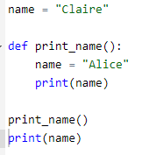

Let’s run the program.



What do you notice? We haven’t changed the global variable. As we didn’t have write access to the global variable, the function has created its own local variable called name and printed that.

To get access the global variable, we need to use the global keyword. This will allow the function to have write access to the variable which has been defined outside of the function. Add the following line straight under the function declaration:

global name

You should have the following code:

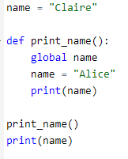

Now when you run the program, you should see that the global variable has been updated.

